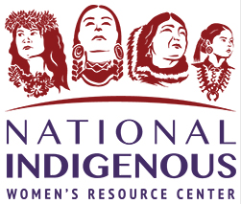
Foundation and Key Principles:
Strengthening the Role of Advocacy in Indian Country Workshop

AGENDA

Day One, April 19, 2022

8:00 Welcome, Opening and Introductions

8:30 Today’s Reality: Violence Against Native Women & Children
Root Causes of Violence: Colonization & Culture

10:00 Exercise and Break

10:20 Connections Between Oppression, Internalized Oppression, Violence & Culturally based Solutions
Necessary Distinctions: Conflict, Abuse, Violence, Domestic Violence, Intimate Partner Violence

12:00 Lunch Break – on your own

1:30 Dynamics and Tactics of Battering: Power and Control, and Tactics

2:45 Break

3:00-4:30 Why Do They Go Back?
Medical Model vs. Grassroots/ Social Change Model
Culturally based Perspective of Role of Advocates

Day Two, April 20

8:30 Role of Advocates

10:00 Break

10:15 Trauma: What is it? Impact & Effects

12:00 Lunch – on your own

1:30 Trauma-informed Approaches & Advocacy

2:45 Break

3:00- 4:30 Basic Advocacy Skills: Relationship Building, Active Listening Skills

Day Three, April 21

8:30 Basic Advocacy Skills: Safety Planning and Protection Orders

10:00 Break

10:15 Working Outside Shelter Doors:
Overview of Ally-building, System Advocacy, Coordinated Community Response, Public Education

12:00 Lunch – on your own

1:30 Shelter & Providing Safe Space: Purpose, Programming, Guidelines

2:45 Break

3:00 Confidentiality and Privacy

3:45 Q & A
Closing

4:15 End of workshop

