Equality Wheel: Natural Life-Supporting Power Descriptions

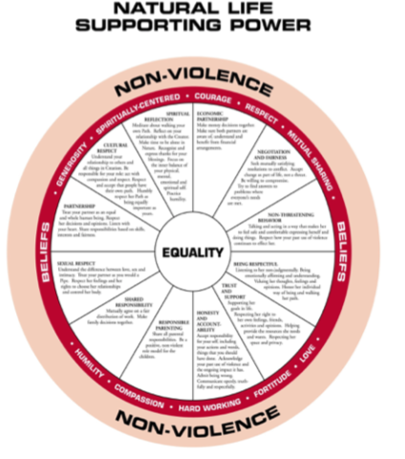
Our work to end violence against Native women and recreate peaceful, harmonious communities is based on reclaiming our traditional values, belief systems and life ways. The natural, traditional life way rests upon values, which are reflected in our behaviors and relationships with all things.

The key values of this life way are: Compassion, respect, generosity, mutual sharing, humility, contributing/industriousness, courage, love and being spiritually centered.

These values are expressed in the manner we behave and relate to others. The following are brief descriptions of how these values can be shown. Challenge yourself to find other ways to create life-supporting power in you and others.

Being Respectful:
Listening to her non-judgmentally. Being emotionally affirming and understanding. Valuing her thoughts, feelings and opinions. Honor her individual way of being and walking her path.

Sexual Respect:
Understand the difference between love, sex and intimacy. Treat your partner as you would a Pipe. Respect her feelings and her rights to choose her relationships and control her body.

Partnership:
Treat your partner as an equal and whole human being. Respect her decisions and opinions. Listen with your heart. Share responsibilities based on skills, interests and fairness.

Cultural Respect:
Understand your relationship to others and all things in Creation. Be responsible for your role: act with compassion and respect. Respect and accept that people have their own path. Humbly respect her Path as being equally important as yours.

Spiritual Reflection:
Meditate about walking your own Path. Reflect on your relationship with the Creator.
Make time to be alone in Nature. Recognize and express thanks for your blessings. Focus on the inner balance of your physical, mental, emotional and spiritual self. Practice humility.

Trust and Support:
Supporting her goals in life. Respecting her right to her own feelings, friends, activities and opinions. Helping provide the resources she needs and wants. Respecting her “space” and privacy.

Honesty and Accountability:
Accept responsibility for your self, including your actions and words, things that you should have done. Acknowledge your past use of violence and the ongoing impact it has. Admit being wrong. Communicate openly, truthfully and respectfully.

Responsible Parenting:
Share all parental responsibilities. Be a positive, non-violent role model. Nurture your children; don’t “baby-sit.” Acknowledge that being an “absent parent” is neglect, not an excuse for not providing financial, emotional and other types of support in the best way you can. Parenting is difficult, get support and words of wisdom from your relatives when needed.

Shared Responsibility:
Mutually agree on a fair distribution of work. Make family decisions together. Do your share without being reminded. Seek help or learn more about the things you are responsible for if needed.

Economic Partnership:
Make money decisions together. Make sure both partners are aware of, understand and benefit from financial arrangements.

Negotiation and Fairness:
Seek mutually satisfying resolutions to conflict. Accept change as part of life, not a threat. Be willing to compromise. Try to find answers to problems where everyone’s needs are met.

Non-Threatening Behavior:
Talking and acting in a way that makes her to feel safe and comfortable expressing herself and doing things. Respect how your past use of violence continues to affect her.

Sacred Circle, National Resource Center to End Violence Against Native Women

