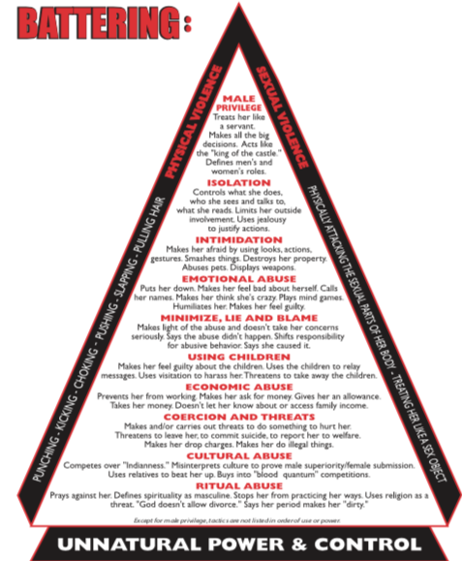
Intimate Partner Violence/Battering is:
- an institutionalized
    - system
    - of over-lapping
    - continuous
    - purposeful
    - violent tactics
    - used to maintain power & control
  - over an intimate partner, usually a woman.

Physical and sexual violence are the “enforcers.” It only has to happen once. After that, it may only take a certain look or gesture that says: “I beat you, raped you once, I can do it again.” Batterers may use tactics differently. Often many are being used all at once. The purpose is the same: power and control. Please remember, if you are leaving to be very careful. Do not warn him you are leaving. Get help. Batterers will increase their violence to maintain control.

The tactics of IPV/battering include many forms of abuse and violence used to maintain power and control without the exertion physical and sexual violence require – and often with less threat of law enforcement involvement because, though potentially lethal, many tactics are not necessarily against the law. Many (not all) of the tactics are described below include. Constant fear for one’s life is a very real result of these tactics.

IPV/Battering is more than a mental health issue. Though, battering of males by females happens, IPV is gender based. In approximately 95% of IPV/battering, the victims are female, the offenders/abusers are male. This form of violence also happens within Two Spirit/LGBTQ relationships. It is serial, violent crime.
Violence against women and domestic violence is rooted in mainstream culture. It is not natural. Before colonization, violence against women and domestic violence were extremely rare within indigenous cultures.

TACTICS:

Male Privilege
It is the permission-giver for all violence against women and general disrespect of ALL women.
- Is trusted and is seen as more credible than women.
- Experiences fewer barriers. More access to money, jobs, etc.
- Gets to do what he wants, when he wants.
- Allows for the expectation that women should be accommodating
- Feeling of entitlement to make big decisions alone expecting women to “make it happen.”
- His/men’s ways is the right way and more valuable than women’s
- Makes men roles superior and women roles inferior.
- No consequences for bad behavior.
- Feeling of entitlement to monopolize conversations and discussions.
- Feeling of entitlement to interrupt and/or ignore women.

Coercion and Threats
- Makes/carries out threats to do harm to the victim, the children or family and friends.
- Threatens to kill the victim, the children, family or friends.
- Threatens to take the children, either legally or by kidnapping.
- Threatens to commit suicide.
- Threatens to report the non-offending parent to welfare.
- Makes the victim do illegal things in order to blackmail.
Intimidation
- Causing fear by using aggressive looks, actions or gestures.
- Smashing things, putting holes in walls and destroying property.
- Killing pets.
- Displaying weapons.
- Reminding her how he has or can hurt her. Verbal threats
- Stalking, including sitting at her place of work, school, etc.

Isolation
- Controls what the person does, sees, talk to and/or read.
- Limits outside involvement by not taking away the car, ensuring the children are always with the non-offending parent, limiting access to money, etc.
- Destroys personal belongings (clothing, etc.).
- Public humiliation.
- Constantly questions (interrogation).
- Takes the phone.
- Constant surveillance.
- Forces her/him to give up supportive relationships and outside connections.

Minimizes, Lies and Blames
- Minimizes the violence
- Ignores and belittles victim’s concerns.
- Says the violence didn’t happen.
- Says the victim caused/deserved/provoked it.
- Shifts responsibility for the violence:
  - “She made me do it.”
  - “I didn’t hit her hard.”
  - “She should have just shut up.”
  - “It was her own fault.”
  - “I had to teach her a lesson.”
  - “I was drunk.”
  - “I was abused as a child; I can’t help it.”

Emotional Abuse
- Put downs and name calling.
- Makes the victim feel crazy, always wrong or stupid.
- Belittles feelings, opinions and reactions.
- Plays mind games.
- Humiliates and criticizes. Tells her she’s a bad mother, wife, woman.
- Makes the victim feel guilty for the batterer’s feelings and behavior.
- Blames the victim for their violence and consequences.
- Stops the individual from doing what she/he needs to or wants to do.
- Tells the victim how to dress, look or act.
- Ignores and neglects the victim.

Abusing Children
- Convinces the children that the violence is the non-offending parents’ fault, that parent is stupid/sick/bad and that the children need a father even if he’s violent.
- Uses the children to relay “mind game” messages.
- Uses visitation and custody to harass or do violence.
- Threatens to take the children far away.
- Believes that children are property
- Convinces her/him that her/he’ll get custody if she/he leaves; she/he stays – abuse/violence continues.
- Does not pay child support (if living in separate households); children may live in poverty.

Economic Abuse
- Prevents the victim from working.
- Makes the victim ask for money or gives an allowance.
- Takes the individual’s money.
- Doesn’t let her/him know about or have access to family income.
- Makes her/him prove how she/he spent money.
- Doesn’t pay child support.
- Spends money on his/her “toys,” not necessities.
- Makes her/him work; he/she doesn’t.

Ritual Abuse
- Makes prayers against her.
- Defines spirituality as masculine.
- Stops her from practicing her ways.
- Uses spiritual ways as a threat.
- Say “God doesn’t allow divorce.”
- Say menstruation time makes her “dirty.”
- Native women don’t sweat with men, don’t sit at drums.
- Says a women’s participation in ceremonies is to support men only.
- Misinterprets Traditions or Bible to justify violence/abuse.

Cultural Abuse
- Competes over “Indianness.”
- Misinterprets culture to prove male superiority and female submission.
- Uses relatives to execute violence.
- Says “real” Native women don’t wear make-up, wear slacks, talk or be independent.
- Denies the spiritual power and role of women.
- Distorting the old-time practice of having more than one wife to justify having affairs, or multiple, simultaneous relationships.
- Participates in ceremonies, then batters the partner, abuses the children.

Collusion
- Any act that discounts, condones, supports or ignores any of the tactics that batterers use to maintain power and control over their partner.
- Makes the abuser/batterer more powerful by reinforcing use of abusive and violent tactics.
- Increases violence against the victim, their children, family and friends.

