Coordinated Community Response

The goal of the coordinated community response (CCR) is safety of women and other survivors, and offender and systems’ accountability.

- This is accomplished by relationship building, education, dialogue and creation of memoranda of understanding or agreement, policy, procedure and protocol, and law and other legislation.
- This initiative is strengthened by ongoing cross-training that emphasizes interaction and includes the operation and history of each agency.

CCR Is:

- An inter-agency effort which prioritizes the safety and integrity of women/ survivors, and their children, and batterer accountability.
- An effort promoting the spiritual and cultural traditions of the sacredness of women and children.
- The establishment of policies, procedures and protocols which consistently prioritize effective, consistent, respectful provision of safety and offender and program/agency accountability.
- An initiative which promotes and honors the leadership and expertise of women who are survivors.
- It does not include staffing, analyzing or case management of women or other survivors who have been battered or raped.

Leadership

Advocates, unlike other professions, provide biased support of relatives who are survivors of domestic, intimate partner and sexual violence. The focus is on these issues emphasizing violence against women and the connections to other oppressions/social injustices, i.e. heterosexism, classism, poverty, racism, etc.

It is the job of advocates to keep the spotlight on the safety and sovereignty of women and other survivors, in addition to offender and systems’ accountability.

As the coordinating agency in the CCR, advocates ensure that the focus is on the operation and effectiveness of agencies and organizations in providing safety, resources and accountability, not the behavior of survivors. This includes protecting the confidentiality of survivors, assuring information is shared only on a need to know basis (not because a confidentiality agreement has been signed.)

Key Members

Coordinated Community Response initiative’s key players are the advocacy program, law enforcement, offender/batterer re-education program and criminal justice system, though it may involve other programs such as child protection, social services or housing agencies.

However, intimate partner violence (IPV)/ battering must be clearly acknowledged as a violent crime, and the coordinated community response as a criminal justice initiative. CCR is not a mental health or social services task force.

CPS, social services, housing and human service agencies may or may not be used by survivors. Systems advocacy includes educating mental health and social service agencies about the dynamics of IPV/battering so they can provide respectful, appropriate services to women/survivors and their children, and prevent collusion with offenders/batterers. It is most appropriate for mental health or social service agencies to act as supportive allies of the coordinated community response.
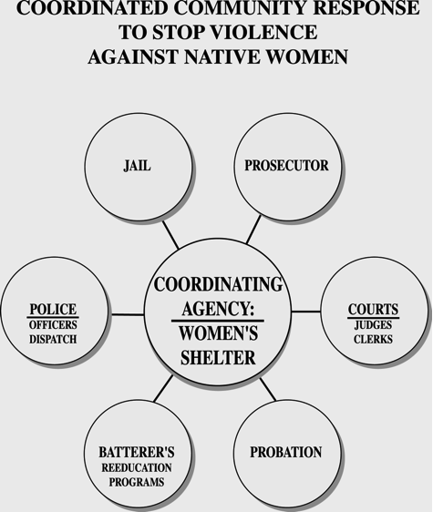

THE COORDINATING AGENCY:
ESSENTIAL ELEMENTS

1. Provide leadership in the development of a common philosophical framework to guide the coordinated community response, ensuring that women's safety is a priority and promotes the spiritual and cultural traditions of the sacredness of women and children.

2. Create consistent, standardized policies, procedures & protocols focused on the operational meaning of safety & integrity of women, acknowledging confidentiality as an integral component.

3. Monitor/track batterers' cases from initial contact through case disposition and probation to ensure practitioner systems and batterer accountability.

4. Coordinate the exchange of information, interagency communication and program decisions on individual/offender cases, ensuring accountability to the survivor, and the entire tribal community.

5. Ensure that all who have been battered/sexually assaulted and at-risk family members, have 24-hour access to resources, support, accurate information and advocacy services.

6. Utilize a combination of sanctions, restrictions and rehabilitation/ re-education services to hold the batterer accountable to the survivor and the goals of the community intervention initiative.

7. Evaluate the coordinated community response from the standpoint of women's safety and personal sovereignty, and the goals of the intervening agencies.

8. Ensure the initiative utilizes traditional life ways as guiding principles, including work to undo harm to women, children and other relatives.
Produced by Sacred Circle /Adapted from Duluth Abuse intervention Project – Adapted by NIWRC 2020

Role of Advocates In Brief:

- Advocate in a manner that respects & validates women’s individuality, experience, decisions and strengths
- Model courage and resistance in the face of fear, oppression, intimidation
- Provide leadership; ensure prioritizing of women’s safety and offender accountability
- Provide 24/7 support, accurate info., crisis response, resources
- Biased support of & accountability to women who have been battered/raped, including defending their confidentiality
- Act as a relative and remain accountable to women who have been battered/raped

Role of Batterers’ Re-Education Programs In Brief:

- Respect the leadership of advocates and expertise of women and other survivors who are battered
- Prioritize women’s/ survivors’ safety, promoting the sacredness of women and children
- Maintain focus on issues of violence, abuse, control and change
- Provide accurate information; teach respectful relationship skills
- Act as a relative and role-model
- Remain accountable to women who have been battered and other survivors

Role of the Criminal Justice System In Brief:

- Respect the leadership of advocates and expertise of women who are battered
- Prioritize women’s/ survivors’ safety and offender accountable
- Understand dynamics of battering and avoid any form of collusion
- Seek convictions; avoid plea agreements
- Proceed without victim testimony
- Act on all violations immediately
- Role model respectful behavior toward women and children

Role of Law Enforcement In Brief:

- Prioritizes women’s safety and offender accountability
- Know dynamics of battering and avoid collusion
- Rapid, consistent response
- Follow law on mandatory arrest consistently
- Document arrests, non-arrests, past offenses etc.
- Police reports available to coordinating agency
- Coordinate with advocates
- Role model respectful behavior towards women

Produced by Sacred Circle – Adapted by NIWRC 2020

